HANDOUT for – Forum Theatre

Objectives:
- to understand the concept of Forum theatre and the theatre of the oppressed.
- linking theatre with human rights issues and education

Theatre of the Oppressed

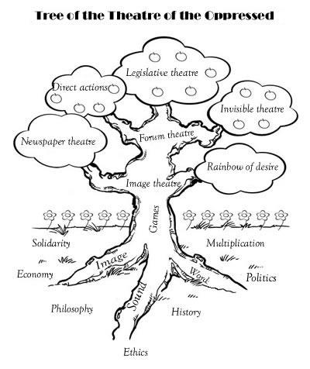
Brazilian theatre-maker, activist and theorist Augusto Boal created the theatre of the oppressed. He was influenced by the work of Paulo Freire. He wanted to create a form of theatre where the people becomes active and they explore, show, analyze and transform the reality which they are living. Theatre of the Oppressed is an arsenal of theatre techniques that seeks to motivate people true dialogue, and create space for participants to practice taking action. The idea behind it is that everyone has the capacity to act in the ”theater” of their own lives. The different techniques is used all over the world for social and political activism, conflict resolution, community building, therapy and governmental legislation. It is also practiced on a grassroots level by community organizers, activists, teachers, social workers and more.

Forum theatre
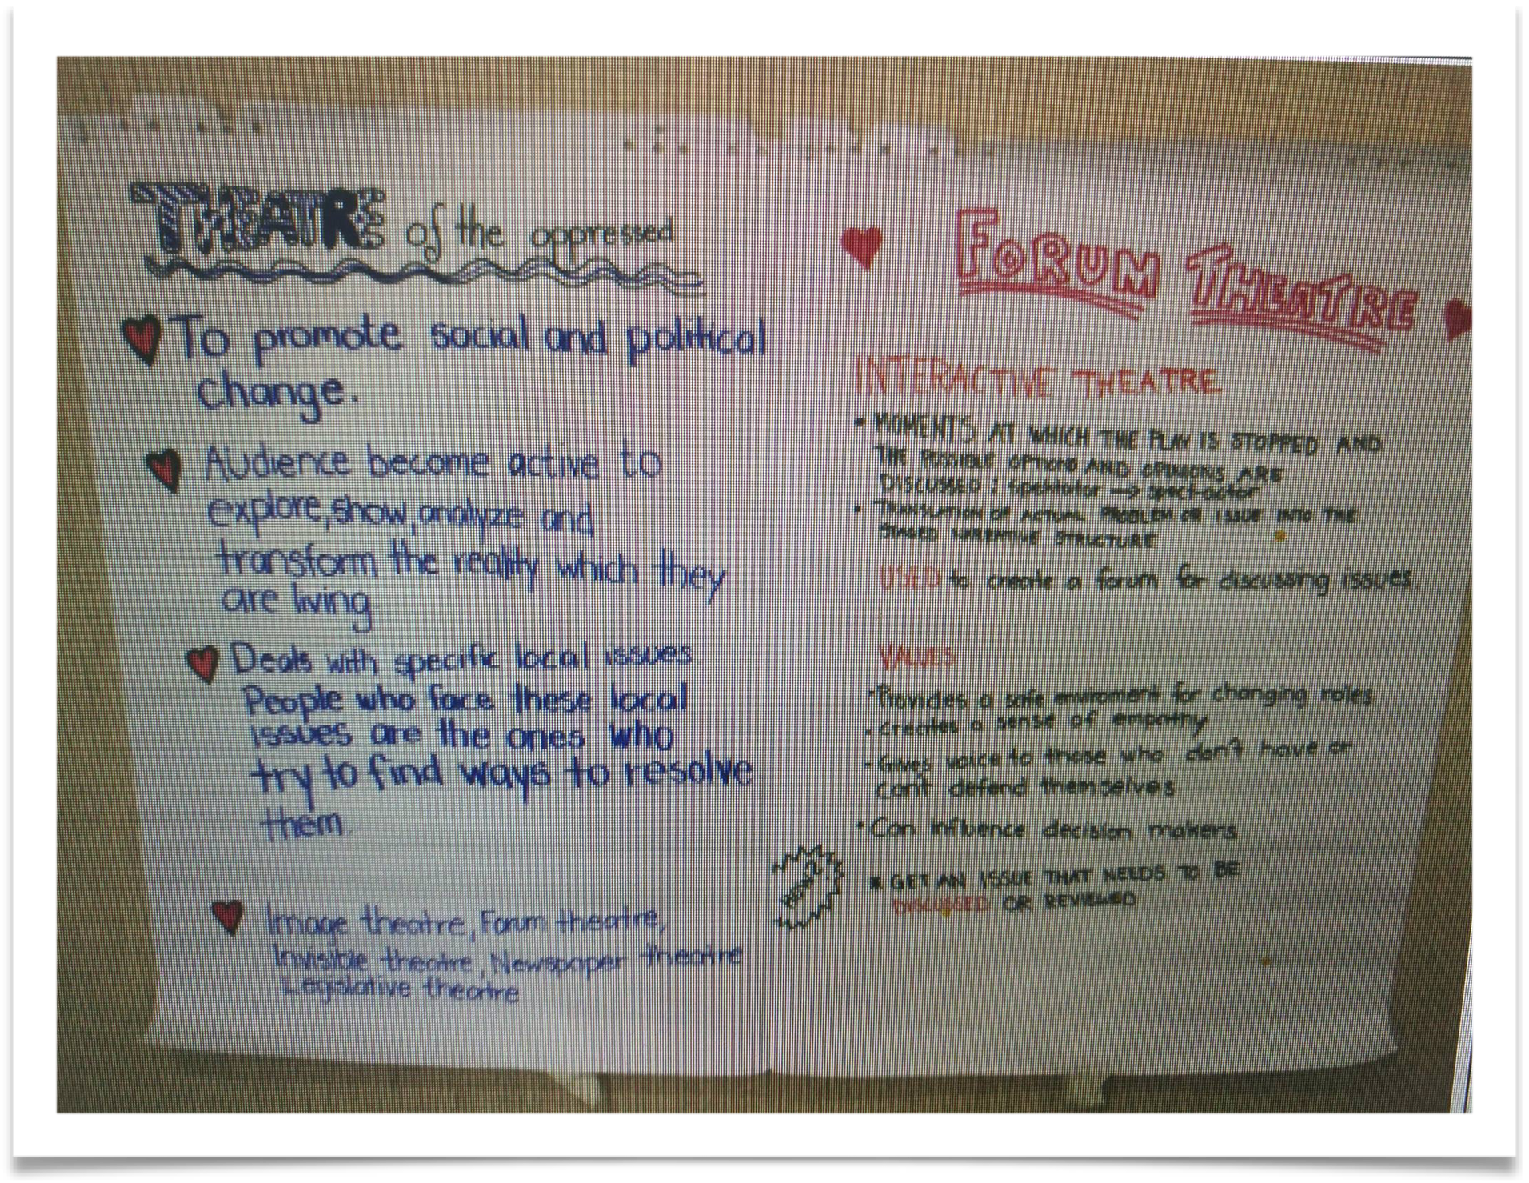

The technique we focused on was Forum Theatre. We introduced the participants the background and aim of theater of the oppressed and forum theatre. Forum Theatre is used to facilitate community dialogue on social issues, involving the audience in the search for transformative actions.

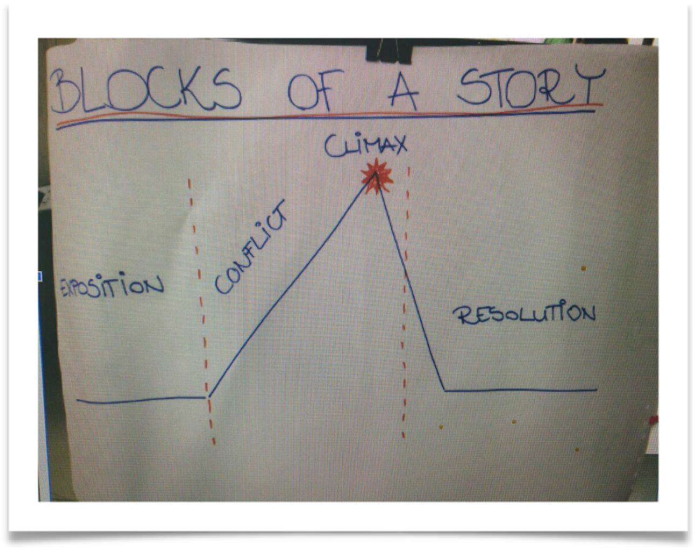

What happens in forum theatre is that the scene that the actors play ends in a climax. Climax is the term used to refer to the part of the story or play where the tension or action reaches its highest part. The climax can be a ”crisis” point in the plot. We introduced the participants a diagram of ”Blocks of the story” to show how the storyline and public narrative is constructed.

To put it into practice we divided the participants in smaller groups and gave them different well known Walt Disney movies to enact the storylines. They were asked to prepare performances inspired by image theatre to prepare 3 still images to show the 1. Initial Situation 2. Conflict 3. Climax of the conflict.

Going deeper to understand the process of the forum theatre

When deciding to use forum theater as a method for community dialogue it is important to understand the key assumptions of forum theatre which are:

- Human beings think with their entire body - The entire body should be involved in the search for alternatives to the unresolved conflicts the audience is experiencing.

- Playing together and using imagination - Helps to de-mechanize from the ”automatic” responses we most likely use when reacting to oppressive situations. Using imagination can help to transform a conflict situation into an opportunity for building other relations between human beings in a broader context. It is impossible to break the cycle of social reproduction of injustice without imagination.

- The oppressed - is someone who experiences a conflict with there people, groups or institutions where legal, economic or cultural power is unbalanced. A conflict situation becomes oppressive when those who benefit from an unbalanced distribution of power use the power to achieve their goals and at the same time make those who have less power suffer and/or prevent them from fulfilling their legitimate rights.

- The oppressed is not a passive victim who accepts the denial of his or hers rights. The oppressed is someone who wants to change her situation, but fails, because of the imbalance of power that exists because of historical, legal and economic structures (e.g. traditional gender roles, laws discriminating against certain groups, unequal economic opportunities etc.)

5. One of the reason why an oppressed person could fail in the fight for her rights is that she interiorized the imbalance of power and ideological structures of domination of those who have more power in a given context. As a consequence, the oppressed sees these structures and practices as normal, desirable and unchangeable. In this cause, to transform the oppressive situation in which a person is in, the oppressed need first of all to change themselves and the way they see their situation and forum theatre can be a way to do it.

6. The oppressed have a wealth of embodied knowledge and theatre can be a way to give value to this knowledge and share it with the community, building individual and collective motivation for change.
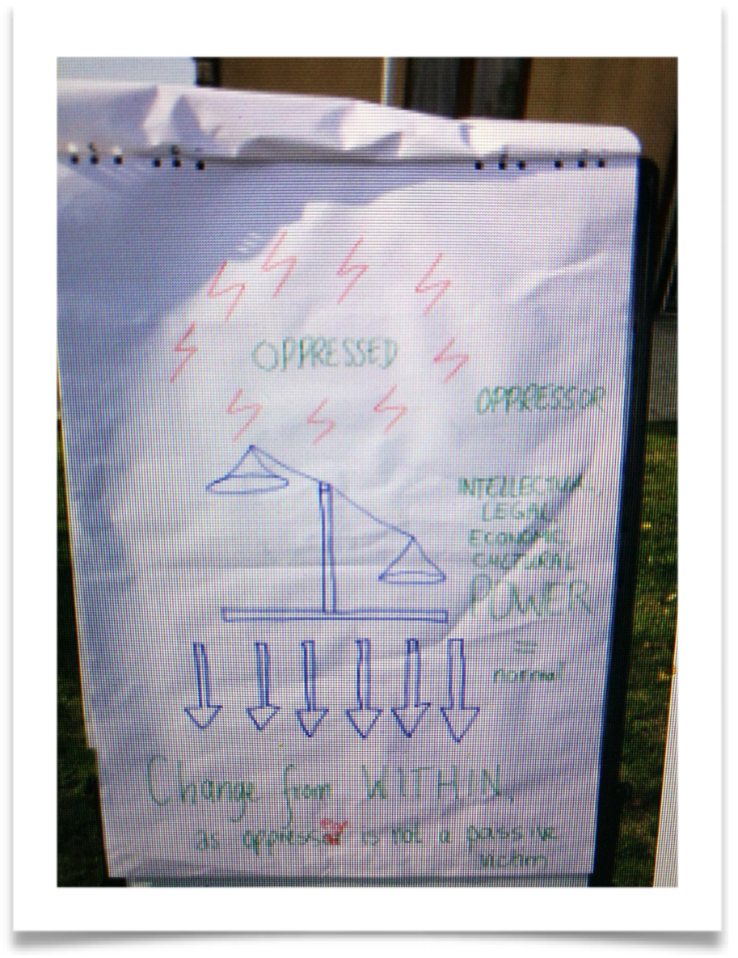
How to use Forum theatre for Community Dialogue

This chapter provides with steps and tips on how you can use forum theatre as a technique in your own community.

Step 1 - The preparation. The facilitator often starts their work in a community and agrees with the community to explore certain issue with them using theatre and games. The issue could be chosen by the community or could be part of an agreed intervention implemented by a development agency (NGO, Government, International Organization etc.). In this case the facilitator can be the Joker and the Joker invites for example 20 community members who have experienced of a certain issue to join a 2-3 day workshop (it is good that the participant can relate to the issue)

Step 2- The participants. They are often people who never did theatre before. When they are invited it is important for the facilitator/joker to point out that no previous theatre training is needed. It is also important to point out that the participants are all experts of their own life and that it is their life, especially the most difficult experiences they are experiencing, that are the most important contribution to the workshop, not their acting skills.

Step 3 - The warm up. It is good to start a workshop with proposing games to get to know each other and exercises to help with the trust in the group. And also it is good to propose improvisation games to activate the senses.

Step 4 - The identification of the stories. When the group has reached a good level of integration the facilitator/joker can invite the participants to split into groups of 6.7 people and share situations of unresolved conflicts currently happening to them or to bother people they care about. The stories should not be chosen on basis of intellectual interest, they should be situations that really bother them, a situations they feel frustrated, upset and sad because they have not yet found a way to respond.

step 5 - Development of the play. The participants choose one story in each group and act it out. What is important to remember is that they are really happening in the community where the play will be presented (Something the audience can relate to).

Step 6 - The presentation of the play to the audience. At the end of the workshop, the community is invited to the Forum theatre play. At the beginning of the play, the joker should facilitates a simple warm-up game involving both the actors and the audience to prepare them to be a part of the forum theatre. The story is then presented to the audience and ends at the climax point, the denial of some of the oppressed rights or legitimate desires.

Step 7 - The participation of the audience. After the play the joker asks the audience if they think that the situation is real, and if it ever happened to them to be in the position of the person who is most oppressed in the scene. In this situation some of the audience may also share experiences of their own lives. Then the Joker explains the rules of the game: ”Now the story will start again, if you see that someone is suffering because of the situation and is making a decision that will lead her/him to suffer again and again raise you hand a say ”FREEZE”. The participants will freeze and and we will listen to your idea”. The joker invites the spectator to put their idea into practice and to come on stage and replace the oppressed caracter, conforming the oppressive characters with the alternative strategy. This is the moment when the person in the audience becomes the spect-actor
The audience observes the changes introduced by the spect-actor and eventually discusses the consequences of the proposed alternatives. After this the play can continue with replacements of different characters at different moments of the play.

Step 8 - The conclusion - After many different alternatives have been tried out on stage it is recommended that the joker concludes the play highlighting that: ”We may not found the solution to the problem we explored, but we testes different alternatives and discussed the consequences of each alternative. Some of the alternatives might work better in certain situations or with certain people. We used theatre as a laboratory to explore social transformation and we hope that something that we experienced here could be taken out there, to the community, and applied individually or collectively, when we see the same oppressive mechanism and choose to shout ”STOP! I want to change the situation!”

Step 9 After the play - After the audience have left the facilitator/joker gathers the actors and proposes a brief ”re-roling ritual” to allow them get rid of the ideology and out of their characters and to relax. Then the joker can ask how they felt during the play, what they noticed in the audience’s replacements and how the play could be improved to facilitate similar processes with different audiences. They can also discuss some follow-up actions for example is there somewhere they could play the same play again.

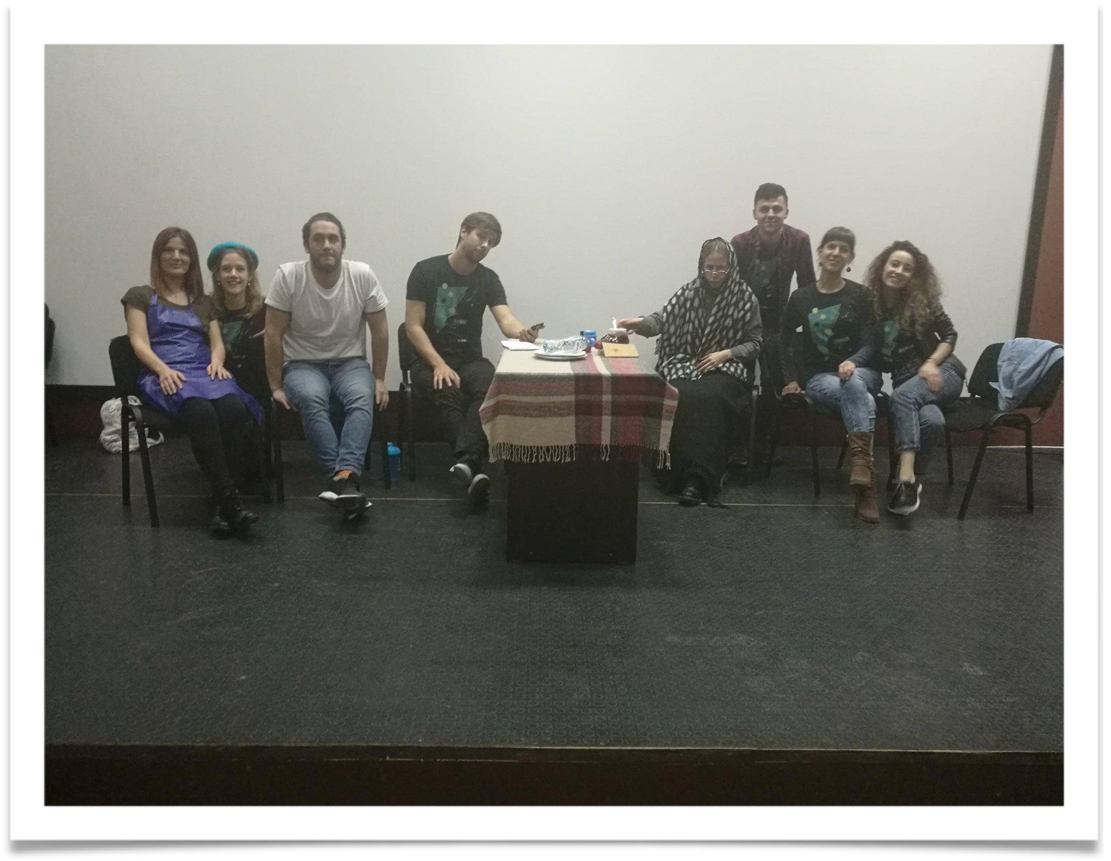
Picture of 1 of the 3 Groups of actors who raised up important issues in Georgia, November 2017

Tips on resources that can be helpful when planning for workshops using forum theatre

Literature:

How to use Forum Theatre for Community Dialogue - A Facilitator’s Handbook - Angelo Miramonti

Theatre of the oppressed - Augusto Boal

Games for actors and non-actors - Augusto goal

Online:

Theatre of the Oppressed a manual for educators - Gopal Midha
http://scholarworks.umass.edu/cgi/viewcontent.cgi?article=1010&context=cie_capstones

Here you can find the rules of the audience and the joker and games that can be used during workshops
https://organizingforpower.files.wordpress.com/2009/03/games-theater-of-oppressed.pdf

